Some fifty years ago I was freed from my involuntary servitude in the mess hall and reported to the NAF China Lake Division in time for Project 1-63, so called as it was the number ONE project for the U.S. Navy in 1963. Project 1-63 being the conventional ordnance demonstration for JFK on the 7th of June 1963. Within the Line Division I was assigned to the A-4 line crew and along with the other recent arrivals to the transient line crew.

China Lake was an airplane nut's paradise, as NAF China Lake had around 60 aircraft consisting of two A-1G Spads, 13 Skyhawks (models A, B, C & E), three TF-10B Skyknights, one F-4A Phantom, 10 Crusaders (models A, B, C & E) , one NTF-9J Cougar, one SP-2E Neptune, two Stoofs (models A &D), three helicopters (CH-19E, SH-34G and SH-34J), one F-1C and four DF-1D Furys, two DT-28B Trojans, 15 QF-9G Cougar drones, two C-117D Skytrains, and one TC-45J Bugsmasher. The VX-5 Vampires had around 20 aircraft consisting of one A-1E and two A-1H Spads, 13 Skyhawks (models B, C & E), one F-4B Phantom, one O-1C Birddog, one T-33B Seastar & one TC-45J Bugsmasher. In addition to the China Lake complement of aircraft, the VX-4 Evaluators were present with another A-4C Skyhawk for the Bullpup demonstration, and the VA-163 Saints and VA-164 Ghost Riders were present with their squadrons complement of A-4B Skyhawks, NPF El Centro was onboard with two TF-9J Cougars for the RAPEC demonstration, and former VX-5 Vampires USMC Project Pilot Maj. Hal Vincent returned with a VMFA-314 Black Knights F-4B Phantom. The VA-165 Boomers also participated in the demo with their A-1H Spads, but weren’t onsite given the lack of space.

In addition to all of the rehearsal activity, the transient line also was extremely busy with USAF transports bringing in the presidential limos; Ike’s 1956 Cadillac and JFK’s 1961 Lincoln Continental, which to me were as different as the administrations were. JFK’s Lincoln Continental was left unguarded next to the line shack and we drooled all over it as none of us had been around a car like this where we grew up. In addition to the presidential limos there were another five-six new Cadillac’s that made up the motorcade. Don’t recall if the two VH-3A Sea King White Tops flew in on their own power, or were flown in on USAF transports.

On the day of, as Ed Sullivan would say, the "really big shew," the press corps Pan Am 707 along with an assortment of C-117’s, C-118’s, C-121’s, C-131’s and C-140’s, were on the airfield with room left over for Air Force One. The airfield Padeyes had all been filled in with cement as there were Pooh-Bahs galore including, besides the President of the United States, Secretary of the Navy Fred Korth, Under Secretary of the Navy Paul Fay, General Maxwell Taylor, Chairman of the Joint Chiefs of Staff, Governor Edmund G. Brown, Senator Clair Engle, Senator Thomas Kuchell, Senator Richard Russell, Congressman Harlan Hagen, Chief of Naval Operations Admiral George Anderson, Capt. Tazwell Shepard (Naval Aide to the President), Rear Admiral G.G. Burkley (Medical Aide), and White House Press Secretary Pierre Salinger. Among other visiting Naval leaders were Admiral John H. Sides, Commander in Chief of the Pacific Fleet; Vice Admiral P.D. Stroop, Commander of Naval Air Forces, Pacific Fleet; Vice Admiral R.T.S. Keith, Commander of theFirst Fleet; General David Shoup, Commandant of the Marine Corps; and Rear Admiral William Blenman (Ret), NOTS CO Captain Blenman’s brother. Also aboard were 250 members of the press. General Maxwell Taylor, Chairman of the Joint Chiefs of Staff, was a notable attendee as he had published "The Uncertain Trumpet" stressing conventional weapons capability vs. all nuclear which JFK had read and the U.S. Navy had apparently heeded.

 I had a front row seat for Air Force Ones arrival and deplaning as I was one of the ground crew. JFK didn’t deplane through the aft door until sometime after everyone else had deplaned. A number of the notables aboard Air Force One, including Gov. Brown, took shelter in the shade of the wing while they waited for the motorcade to depart for the Presidential viewing stands on G Range. Unlike the Pan Am Stewardii who graced the Presidential viewing stands my view of the demonstration wasn’t great as I stayed at the airfield to help launch, fuel and recover aircraft.

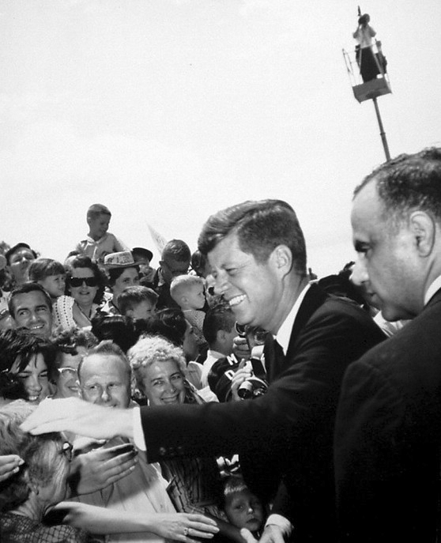Visitors by the thousands (including my wife who was a Navy dependent at China Lake) poured through the gates and as described in the Rocketeer “Cheering throngs, racing for vantage points for a fleeting glimpse of President John F. Kennedy as his huge 707 jet plane settled at the Naval Air Facility, shattered the mood of calm preparation that had prevailed during the final few hours. Secret Service and Station Security officers, aided by newly arrived Seamen Guardsmen, found the task of containing the crowd's enthusiasm one of the biggest problems of the day. By early afternoon, the effort became pointless. The handclasp, symbol of brotherhood and friendship down through the ages, served as a prime objective for thousands of spectators who tore through police lines to touch the President's hand. They found a willing one awaiting theirs.”

After the Presidential motorcade left for the viewing stands on G Range most of the visitors left for Mainside to cheer the Presidential motorcade following the airpower demonstration. We got busy with the post demonstration meet & greet, the USMC barracks stand-down and the President’s speech. The area between hangar 2 and hangar 3 was set up for the meet and greet with representative aircraft and crew from each event lined up on the west side of hangar 3 running from south to north. The quadrant north of that was set up for the Marine Corps Honor Guard consisting of three officers and 64 enlisted men who were inspected by JFK prior to his departure. Also present in that area were the 33-member Fleet Marine Force Pacific band from El Toro and the China Lake Marine Detachment who retired the Barracks colors as it was their last official appearance before being disestablished after 18 years of duty at NOTS. The south side of the quadrant included the Presidents podium, two USMC SH-3A Sea Kings and two USMC VH-3A Marine One White Tops.

Twelve NAF pilots and 10 pilots and three crewmen from the VX-5 Vampires joined 27 pilots from Carrier Air Groups 11 and 16 to stage the range-blasting aerial demonstration, no doubt aided by targets that were well laced with aviation fuel and HE.

The NAF pilots were LCdr. Andy L. Berthelson (DF-1D), Lt. David F. Callahan (A-4A 137818), Lt. W.D. “Gus” Jones (A-4C 147680), Lt. Jim L. Kistler (F-8B 144443), Lt. Earl P. McBride (F-8D 147049), Lt. J. Mark Morgan (A-4A 137813), Lt. Larry O. Peechatka (DF-1D), LCdr. Carl W. “Rocky” Rochester (A-4B 144925), LCdr Howie Rutledge (F-8A 144435), Cdr. Jack A. Sickle (A-4B 142085), Lt. Rod J. Sikes (DT-28B 138355), Lt. A. L. "Tony" Tambini (A-4E 149969), USMC MAJ Bob Walker (F-8D 147047) and Lt. D.W. Johnston (NA-4C 145063).

The VX-5 Vampires pilots and crewmen were LCdr. Gary H. Palmer (A-4C 145068, XE-4), USMC Capt. Ray R. Powell (A-4C 145075, XE-3), Lt. Robert L. Boyd (A-4C 145127, XE-9), Lt. W.A. Barr (A-4C 145112, XE-8), Lt. Robert V. Rice (A-4E 149658, XE-00), Lt. Elmer. G. “Gil” Borgardt (A-4E 149657, XE-22), Lt. Paul F. McCarthy (F-4B 150440) and his crewman PH1 J.L. Pierce, USMC Major Paul B. “Tex” Montague (A-4C), USAF Capt. Thomas R. Brock (A-4C), Cdr. Charles H. Lindberg (A-3) and his crewmen, Lt. E.E. Austin and AQ2 Alan P. Oberst (VAH-12 A-3B 142406).

The A-1H Spad pilots from the VA-165 Boomers were Cdr. R. Houck (AH-501), Cdr. L.L. Andrews (AH-502), LCdr. W.S. “Bill” Jett, III (AH-511), LCdr. G.T. Pappas (AH-508), Lt. L.H. Taylor (AH-507), Lt. O.B. Pollock (AH-503), Lt. (jg) A.L. Goldsmith (AH-513), Lt. (jg) G.J. Mafort (AH-506), Lt. (jg) J.W. Wilson (AH-514), Lt. (jg) P.S. Ferrentino (AH-512), Lt. (jg) A.G. Harrison (AH-505), and Lt. (jg) S.A. Pelszynski (AH-500).

The VA-163 Saints A-4B Skyhawk pilots were LCdr. Harry T. Jenkins (AH-300), Lt. (jg) J.A. Cade (AH-305), Cdr. M.D. Short (AH-307), USAF Capt. R.C. Vickery (AH-310), Lt. (jg) M.D. Hewett (AH-311), and Lt. (jg) W.R. McGowen (AH-313.) The VA-164 Ghost Riders A-4B Skyhawk pilots were Cdr. C.A. “Charlie” Banks, Jr. (144907, AH-401), Lt. E.D. Shropshire, Jr. (AH-403), Lt. (jg) H.C. Farley, Jr. (142842 AH-407), LCdr. R.M. "Dutch" Netherland (AH-415), Lt. (jg) D.C. Clarke, Jr. (AH-417), Lt. H.C. North, Jr. (AH-4xx), Lt. (jg) R.M. Mulrooney (AH-4xx), and Lt. (jg) C.H. Hubbard (AH-4xx.) The A-4C Skyhawk pilot from the VX-4 Evaluators was Lindsey (149511, XF-40).

The RF-8A Crusader pilots from VFP-63 Det. G were LCdr. Rockwell, Lt. “Pete” Midgarden and Lt. (jg) Edward (one of the Crusaders was 144619, PP-935) who made the pre and post demonstration photo runs flying off of and returning to the U.S.S. Kitty Hawk. NPF El Centro Lt. Tom Reed in TF-9J Cougar (144448) flew the RAPEC demonstration. The F-8A Crusader pilots from the VF-162 Hunters were CDR Fred Nevitt (AH-200) and two unknown pilots in (AH-2xx) made 20mm strafing runs.

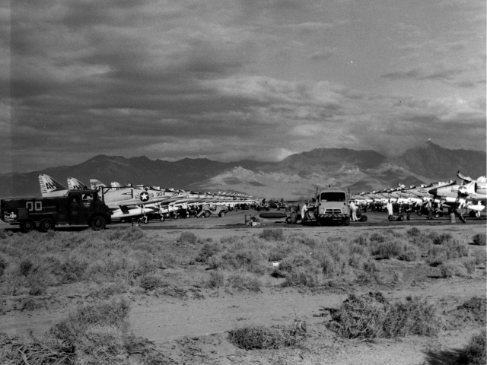 Other than the HVAR’s, Sidewinder, photo and two strafing runs it was a Skyhawk show with Shrike and Bullpup missiles, napalm, Zuni FFARs, HIPEG, Gladeye Lazy Dogs, Padeye smoke screens, Sadeye cluster bombs, retarded fin Snakeyes, Walleye and Weteye demonstrations. In fairness I should note that USMC Maj. Hal Vincent and his VMFA-314 Black Knights F-4B Phantom (150458, VW-19) with a load of 24 Mk-82 500 lb. bombs and the similarly configured VX-5 Vampires F-4B (150440, XE-13) did manage to reduce to splinters one or more of the wooden ship targets constructed for the event.

And now the blow-by-blow for the really big show narrated by VX-5 Vampires XO Cdr. Joseph E. Schwager. I should note that there was a separate classified script for events 10-28 that was narrated for the press by NOT's Technical Officer Captain Carl O. Holmquist.

Commentary for NOTS 1-63

Introduction

(Boatswain pipes "All Hands")

Mr. President, distinguished guests: The demonstrations you have witnessed at sea have shown how the Navy can move through a hostile air and submarine environment to enable Navy and Marine forces to project U.S. power to almost any trouble spot in the world. Today we shall see a projection of that power - - the air support required by our tactical ground forces.

Your host today is the Naval Ordnance Test Station (NOTS), a laboratory of the Bureau of Naval Weapons, commanded by Captain Charles Blenman from Tucson, AZ. Its Technical Director is Dr. William B. McLean of Pasadena, CA. I am CDR Schwager, your narrator.

Most of the weapons you will see today were born at this Station. They were conceived In Michelson Laboratory, which you will visit later, and developed and tested on these ranges.

The purpose of this demonstration is to contrast our stockpiled limited war weapons - - their tactics - - and their effects with some of the more effective limited war weapons now under development. We believe that these new designs will give our Fleet, our Sister Services and our Allies greater capabilities to meet limited war situations through the availability of weapons of greater effectiveness, economy and simplicity.

A miniature carrier deck-edge elevator now ascending to your level in the center stand will lift displays of the newer weapons at appropriate times during the program.

On your immediate right front, Mr. President, and for your convenience, a photographic display will, when suitable, illustrate aircraft which are configured with the weapons to be delivered.

Television will provide close-ups of key events and will rake targets after each attack so that you may assess target damage.

All aircraft will approach from your right and will generally be difficult to sea until close in -- a disadvantage which we sincerely hope will be shared by defense units on actual strikes. In order to improve your chances for early detection, however, some of the aircraft will trail smoke. Furthermoreto assist you in locating the target for certain events, I will mark target position with a smoke signal as I am now doing for position "A".

Military and civilian personnel of the Naval Ordnance Test Station, the Naval Air Facility and Air Development Squadron Five, all based at China Lake; Carrier Air Group 16, operating from U.S.S. Oriskany; and Carrier Air Group 11, operating from U.S.S. Kitty Hawk, have combined their efforts into this demonstration.

Our first 9 events illustrate current conventional air-strike capabilities of carrier launched attacks. These sorties will be flown by pilots from Carrier Air Group 16, commanded by CDR "Bob" Baldwin of Fargo, ND.

With your permission, we will get under way.

EVENT #1: One VFP-63 Det. G RF-8A Crusader Photo-Flash Salute

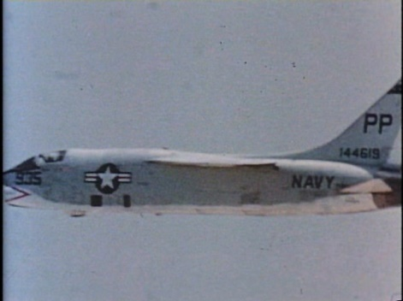Photo reconnaissance before and after an air strike provides the fast carrier task force with hard intelligence. A flare equipped Chance Vought Crusader photographed our demonstration target complex last night to simulate a carrier pre-strike reconnaissance sortie. This photograph was shown to you prior to your departure from Kitty Hawk. The same pilot, LCDR Rockwell from San Diego, CA, and aircraft now approaches, Sir, to fire a photo-flash salute in your honor while executing a loop maneuver.

This aircraft will return at the conclusion of the Fleet readiness demonstration and perform a post-strike photo reconnaissance sortie to record target destruction.

EVENT #2: Four VA-165 Boomers A-1H Skyraiders 50**°** G.P. Delivery

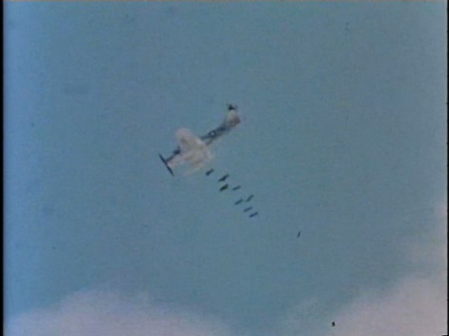Approaching at 9,000 feet altitude, Douglas Skyraiders (AH-500, AH-502, AH-503 & AH-514) each loaded with 12-250 lb. bomb, are nearing their roll-in point for a 30° glide attack. The flight, led by CDR Andrews from Brockton, MA will saturate the target near position "B" with 6 tons of bombs.

This aircraft and tactic were used extensively in Korea for both close-air support and carrier air-strike sorties. Skyraiders are still used for many missions such as low altitude, long range strikes.

Originally built in 1945, the propeller-driven Skyraider has evolved through 7 basic models encompassing 49 different versions in its long life. Fleet pilots affectionately call the Skyraider a "SPAD." Carrier launched Skyraiders operated in Korea with bomb loads in excess of 10,500 lbs., which, incidentally, is greater than the capacity of the B-17 Flying Fortress. Few aircraft can match the remarkable Skyraiders versatility.

EVENT #3 Four VA-164 A-4B Skyhawks MK-81 Loft Delivery

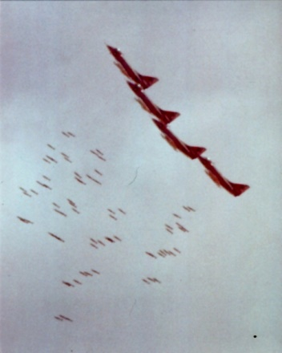Closing at 450 knots near ground level, Douglas Skyhawk jets (AH-401, AH-403, AH-407, AH-417,) each with 18-250 lb. approach their pull-up point for a loft attack.

Both aircraft and tactic are an example of modern carrier air-strike potential. The Skyhawk is the Fleet’s primary light attack aircraft and the tactic provides stand-off for protection from modern target defenses. Fast, low level penetrations like this are difficult for an enemy to detect and counter.

Arcing upward, shortly, and releasing their ordnance, the Skyhawks lead by CDR Banks, from Marshall, Texas, will execute escape tactics while 9 tons of bombs hurtle for 3 miles toward the target beyond position "C" not marked by smoke. This low-level stand-off tactic is devastatingly effective against heavily defended areas.

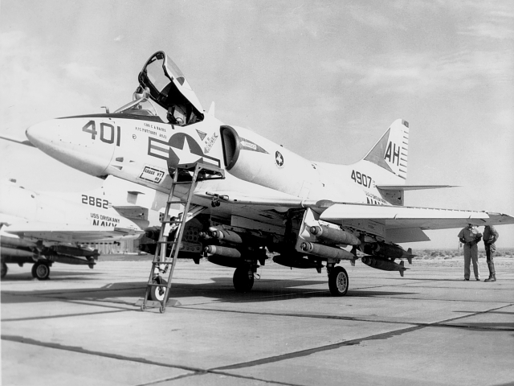 A Multiple Carriage Bomb-Rack developed by the Navy gives the Douglas Skyhawk and other jets up to 6 times the number of numbs they could otherwise carry. Note that the Skyhawks in this event have lofted 1-½ times the bomb load dropped by the older Skyraiders in the previous event.

EVENT #4: Two VA-163 A-4B Skyhawks Bullpup Demonstration

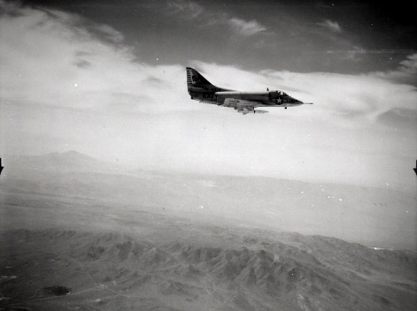 Although aircraft vulnerability is reduced by stand-off attained with the loft tactic just demonstrated, this technique lacks the accuracy required for attacking point targets, and is generally limited to stationary or area targets on pre-planned strikes. To increase accuracy and versatility to attack small targets of opportunity from a distance, the Navy has developed the supersonic, guided, air-to-surface Bullpup missile.

Visually guided by the pilot through radio-control after launch, Bullpup "A" can accurately deliver a 250 lb. warhead against small hard targets, mobile or fixed, from ranges up to 9 miles.

Attacking from 7,000 feet altitude two Douglas Skyhawks (AH-307, AH-311) led by CDR Short from Warsaw, MD, will each fire a Bullpup missile against the bright green target “D” on your far left.

(After firing)

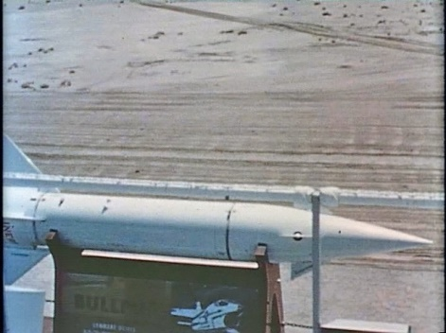Thiokol Corp. developed the liquid propellant for Bullpups now in the Fleet. With the Martin Company as prime contractor, the Navy developed Bullpup has been manufactured in quantity for the Navy and Air Force and has been released to NATO.

EVENT #5: Four VA-165 Boomers A-1H Skyraiders HVAR Rocket Delivery

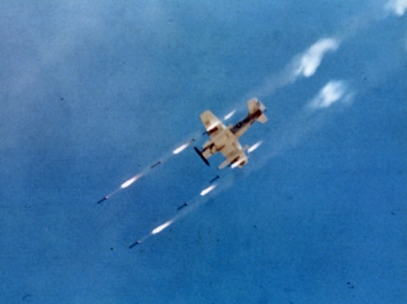Having softened an enemy’s defenses with stand-off weapons or tactics, close air support sorties such as rocket attacks can press nearer to targets for more assured kills.

We will demonstrate our rocket development evolution by featuring increasingly more powerful rocket attacks in the next three events.

We begin with the 5-inch High Velocity Aircraft Rocket now called HVAR but known by old-timers as "Holy Moses." Developed at NOTS late in World War II, HVARS were fired during the Battle of the Bulge. HVARS were also used extensively in Korea and are still a potent weapon in our ordnance stockpile.

Equipped with fixed fins, HVARS must be mounted individually on an aircraft. Thus, the number of external ordnance stations determines how many HVARS can be carried. The Skyraider, with 12 stations, carried more of these weapons than our jet attack aircraft which, for aerodynamic reasons, have fewer stations.

In a moment, a flight of Douglas Skyraiders (AH-507, AH-511, AH-512, AH-517) led by LCDR “Bill” Jett from Charleston, South Carolina, will dive on the ship target near position “E” for a HVAR attack.

EVENT *#* 6: Four VA-165 Boomers A-1H Skyraiders 2.75" FFAR Delivery

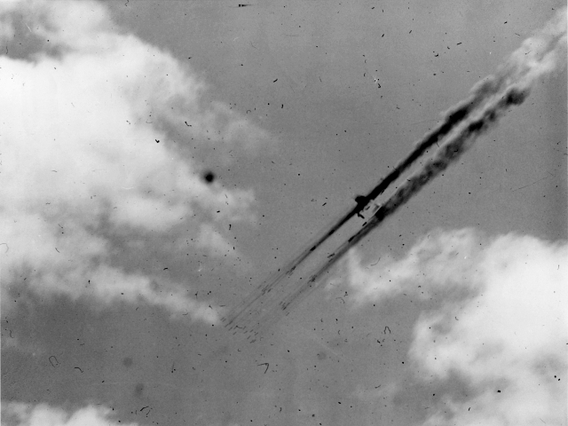Our next demonstration will feature the 2.75-inch folding-fin aircraft rocket. Because of its folding-fin, quantities of these rockets can be loaded into pods for increased firepower. Each Skyraider in the next event carries 12 pods separately loaded with 7 rockets for a total of 84 each. This is about twice the destructive power witnessed in the preceding HVAR demonstration.

Developed, production-engineered and pilot-produced here at NOTS, over 16 million of these 2.75-inch rockets have been manufactures for the Navy, Air Force and Army.

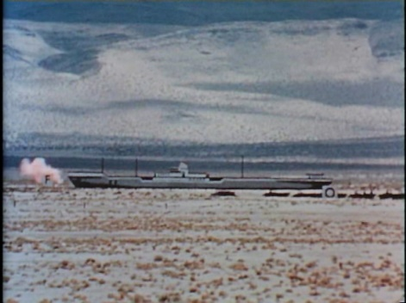 Overhead at 8,000 feet, Douglas Skyraiders (AH-501, AH-505, AH-506, AH-508) led by CDR Houck from South Bend, IN, prepare to salvo a deluge of 2.75-inch folding-fin aircraft rockets against the ship target near position "F".

(Use after the delivery)

Shelf price is now down to less than $55 per copy. Sizeable quantities are being produced by Canada and other NATO countries.

EVENT #7: Four VA-164 Ghost Riders A-4B Skyhawks ZUNI Rocket Delivery

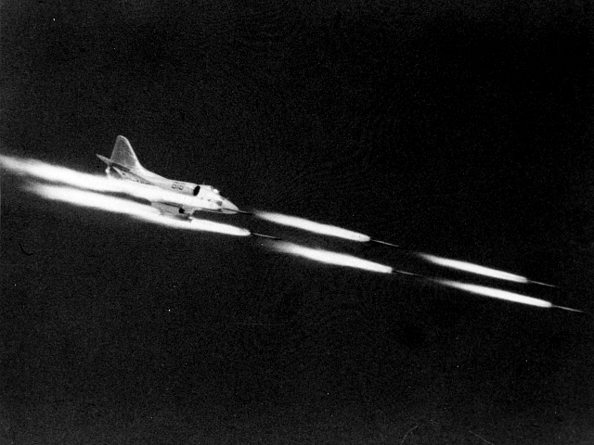The need to extend a multiple 5 inch rocket capability to our jet attack aircraft led to the completion at NOTS, late in 1958, of the ZUNI rocket.

ZUNI is a 5-inch, high performance, folding fin aircraft rocket suitable for air-to-air and air-to-ground missions. Four interchangeable warheads permit the weapon to be tailored to the target. Carried in a pod of 4 suspended from an ordnance station, the rockets may be fired singly or in salvo. ZUNI has twice the velocity of the HVAR and ten times the warhead weight of the 2.75 inch FFAR previously demonstrated.

A flight of VA-164 Douglas Skyhawk jets (AH-415 and three others) at 7,000 feet altitude, each armed with 8 ZUNI’s in two pods of four and led by LCDR "Dutch" Netherland from Beaver, Pennsylvania, attack the ship target near position "G" in a 30° glide.

(After release)

ZUNI is respected as one of our finest pieces of ordnance and is also used by the Air Force.

Released for Fleet use in 1960, ZUNI has quadrupled our jet rocket attack capability.

EVENT #8: Four VA-163 Saints A-4B Skyhawks Napalm Delivery

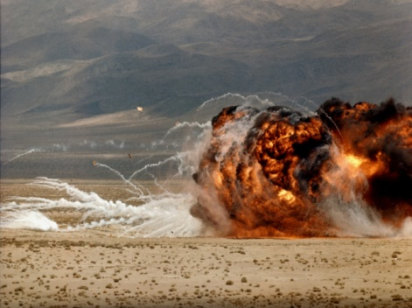 Having subdued an enemy’s defenses with bomb and rocket assaults, low level napalm attacks to burn surface targets can be pressed to close quarters.

Few assaults are a fearsome as a Napalm attacks, NOTS is striving to increase the effectiveness of this devastating kill mechanism and to be more compatible with modern high performance aircraft.

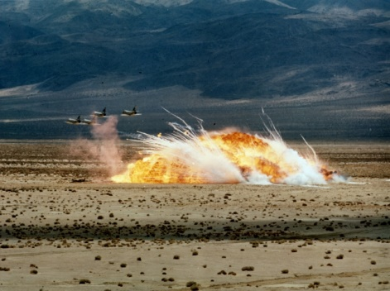In the distance at ground level, Douglas Skyhawks AH-300, AH-305, AH-310, AH-313) led by LCDR Harry Jenkins from Suitland, MD, each with 2 Napalm bombs, close at 500 knots to saturate area "H" with an inferno of fire.

(After attack is completed)

Better and more effective additives, new fuels and improved igniters are sought as well as new techniques to hold flames on the target for increased fire damage.

EVENT #9: Two VFP-63 Det. G RF-8A Crusaders Photo-Reconnaissance

With the air-strike completed, Crusader’s, one high and one low, led by LT “Pete” Midgarden from Hoople, ND, return to execute post-strike photo-reconnaissance of the target area. The pictures they take will be processed for your review

Introduction: RDT&E Portion Confidential Narrative

Although the preceding events have been separated by lengthy intervals for demonstration purposes, one should sense the deadly effectiveness of a modern coordinated rapid fire, carrier-launched air-strike. These missions have illustrated various tactics and conventional weapons currently used by our Naval Air Forces.

By way of contrast, the remainder of our program will be devoted to new weapons presently undergoing development or test here at the Naval Ordnance Test Station and is classified CONFIDENTIAL. Flight demonstrations will be made by pilots from the Naval Air Facility commanded by Captain Jack Hough from Council Bluffs, IA, and Air Development Squadron Five, commanded by CDR Harry O’Connor from Winthrop, MA.

The Naval Ordnance Test Station is the Navy’s largest in-house weapons laboratory. Managed by the Bureau of Naval Weapons, it is our mission to perform research and development and to support the Fleet’s operational requirements for weapons. This is pursued in a close, personal relationship between operationally experienced Naval Personnel and capable civilian scientists, engineers and technicians here at China Lake. This team work lends itself to the timely production, by industry, of effective and versatile weapons for the Fleet. Indeed, NOTS can boast that nearly all of the Navy's air-to-air and air-to-surface weapons have been developed here -- many of which are also used by the Air Force, Army, NATO and other countries.

Some of this devices you are about to see are in the test and evaluation stage and will soon be available to the Fleet. Others, however, are still undergoing feasibility tests or development and will, of necessity, utilize laboratory models which have not yet been perfected to our standards of reliability. May I emphasize that the events to follow Illustrate weapons in various stages of development and test. Like parents bracing themselves for the possible embarrassments of a child's first recital, we continue.

Event #10: One NAF DT-28B Trojan Strafing Demonstration & Lead-in Information

As an introduction to the RDT&E part of our program, we will trace the recent evolution in aircraft guns.

During World War II, 50 caliber machine guns were used for both aerial combat and strafing. Although missiles are now our primary air-to-air weapons, strafing missions still require aircraft to carry guns. Fleet aircraft, today, mount built-in 20mm automatic cannons. In the near future they will use a removable, externally-carried uniquely-designed high performance gun called HIPEG which reliably fires stockpiled ammunition at a fantastic rate.

The next three events will illustrate the evolution leading to HIPEG. We will f1y consecutive strafing demonstrations using 50 caliber machine guns, 20mm automatic cannons and, finally HIPEG - - all on the same target complex near position "I." Your television will show close-ups for Damage assessment.

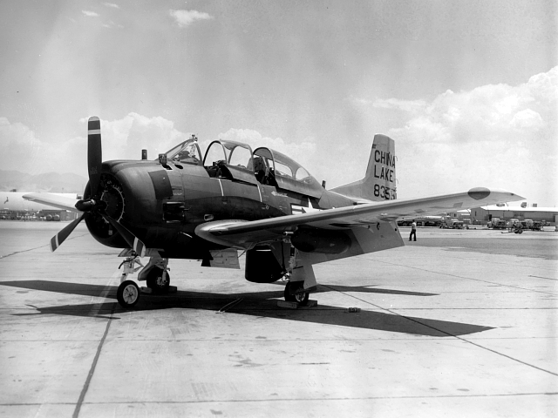First to attack is LT Sikes from Port Lavaca, TX, flying a North American DT-28B Trojan trainer (BuNo 138355) equipped with two 50 caliber machine guns which fire at a rate of about 750 rounds per minute. Weapons of this type were our primary aircraft gun during World War II and, today, are used by our Friends in South East Asia.

Event #11: Three VF-162 Hunters F-8A Crusaders Strafing Demonstration

The 20mm aircraft cannon was employed in Korea, and remains today our primary aircraft, gun. CDR Fred Nevitt from La Jolla, California, leading a flight of Chance Vought Crusader’s will demonstrate this weapon. Each Crusader mounts four 20mm guns with a total firing rate of 4,000 rounds per minute.

(Fill in comments if needed)

It is difficult for air-strike planners to ignore the multiple uses of guns. Airborne automatic weapons are a favorite selection for interdiction and close support missions. Hot-shot pilots have always shown a flare for shoot-em-up sorties which give them a license to raid enemy target ranging from trains to privys.

Event #12: One NAF A-4A Skyhawk HIPEG Strafing Demonstration

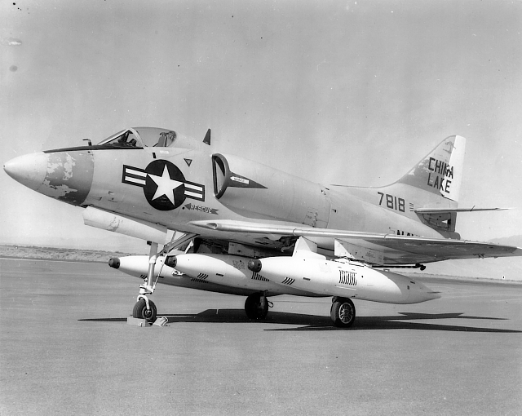A single Douglas Skyhawk (BuNo 137818) armed with HIPEG (our latest automatic gun weapon) has the strafing fire-power just demonstrated by three Crusaders. LT Callahan from Lynn, MA, approaches in a Skyhawk equipped with three externally mounted HIPEG 20mm cannon pods firing stockpiled ammunition at a rate of 12,000 rounds per minute. This gun fires faster per barrel than any other automatic weapon ever developed.

(After HIPEG fires)

Models tested for reliability have fired over 50,000 rounds without stoppage. HIPEG is readily hung from an ordnance station like a bomb or rocket, and can be quickly interchanged with other ordnance. This feature gives us flexibility in the selection of ordnance loads for targets and enhances the versatility of our aircraft for close support missions.

EVENT 13: One NAF A-4B Skyhawk Walleye Captive Flight Demonstration

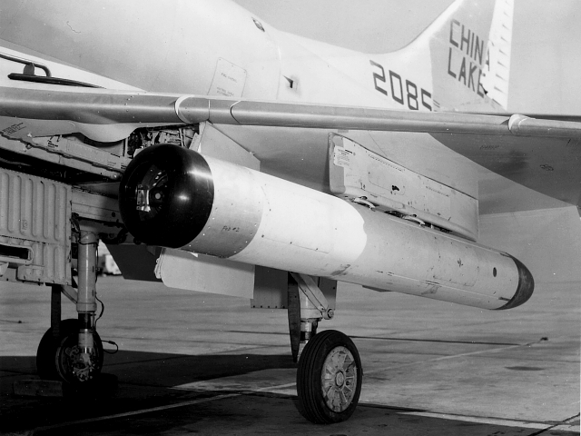Accurate air attacks against heavily defended hard targets are difficult. An accurate stand-off, air-to-surface homing weapon is required to neutralize such targets. Walleye is such a weapon. Its feasibility has been recently demonstrated and development is now underway at NOTS.

Walleye is an air-to-surface, homing, glide weapon. Its mission is to passively home on and destroy tactical land and sea targets which have been visually acquired and iden­tified from the launching aircraft. An internal automatic tracking television system first demonstrated in principle by the Naval Ordnance Laboratory, Corona, provides the weapon with its own guidance and thus frees the pilot of any control responsibility after release. Since the guidance system is entirely passive, there is no known way to jam this weapon.

Walleye is still is the feasibility stage and, unfortunately, cannot be demonstrated today as a completed weapon. However we will illustrate the Walleye guidance system with a live telecast relayed from a captive Walleye in flight so you may see on your television monitor exactly what the Walleye sees as it homes on target "J." Far to the south a Douglas Skyhawk (BuNo 142085), carrying Walleye, approaches to attack. The pilot, CDR Jack Sickel from Annapolis, MD, will not release the weapon. Instead, he will fly a trajectory, similar to a released weapon, as close to the target as possible. At the last moment he will break-away. Bear in mind that this telecast is not part of the tactical weapon.

In operation the pilot first visually acquires and identifies the target. He then shifts his attention to a television monitor on his instrument panel, which shows the target, as seen by the weapon’s television camera. A set of double cross-hairs, in the center of the television picture indicates weapon aim point. The pilot maneuvers his aircraft to place the double cross-hairs over the target and switches the weapon to automatic track. After checking weapon tracking action, the pilot releases Walleye then turns his aircraft to attack other targets or leave the area.

Many of us believe that Walleye will be the most accurate and effective air-to-surface conventional weapon ever developed, and will vastly reduce the number of sorties or weapons needed to destroy a target. Its size and weight will make the WALLEYE compatible with both light attack and fighter aircraft. Stand-off ranges of 20 miles or more will drastically reduce vulnerability for attacking aircraft.

EVENT #14: Walleye Warhead Firing Demonstration

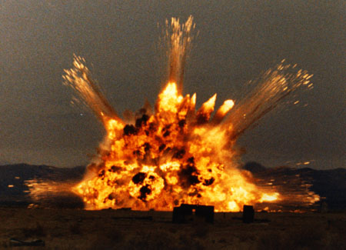The warhead for Walleye is a linear shaped explosive charge with cross-section in the form of an 8-point star.

Directly in front of you, at the distant position "K" stands a partial bridge struc­ture over a Walleye warhead flanked by a tank and a truck. Television shows a close-up of the installation. Watch while we detonate the warhead in a static firing.

(Pause for firing)

The warhead is of unique design. When it detonates, the gaseous jets created by the explosion are focused outward. They travel at such extremely high velocity that hard targets are literally ripped apart at close ranges. This unique warhead, if accurately delivered, is much more effective than regular blast warheads against most types of hard targets. Walleye is expected to achieve the necessary accuracy required to make this new warhead design effective.

Event 15: NAF A-4A Skyhawk Gladeye

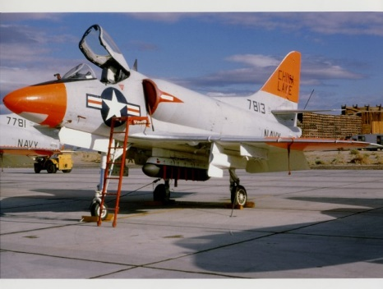Many tactical problems, such as deployed enemy troops, require large areas to be covered with anti-personnel devices or other materials. The next two flight events will feature NOTS developed dispenser weapons which spread a variety of munitions.

An airborne dispenser, developed by NOTS, incorporates a modular principal in which various loads in any combination may be carried in each of seven canisters supported by a single strength member or strong-back hung from an ordnance station. The pilot may elect to drop the canisters individually or in ripple. Since the strong-back (which is the principal part of the device) remains attached to the aircraft, this weapon is operationally inex­pensive and reduces logistic problems.

LT. Morgan from Greenwell Springs, LA, in a Douglas Skyhawk (BuNo 137813) armed with modular dispensers will attack a column of 40 balloons at position "L” which simulates troops along a road. Each dispenser is loaded with 35,000 anti-personnel missiles which are inert, 41 caliber, steel projectiles fitted with tail fins. This is a silent weapon; no explosives are involved.

(After attack):

I estimate that ___ of the balloons were hit. The projectiles in the event received their killing power from aircraft motion and gravity alone. Each missile struck with the velocity and intact of a 45 caliber bullet fired at close range. Vast quantities of these missiles have been stockpiled.

Houston-Fearless Associates of Terrenes, California, manufactures this modular dispenser.

EVENT *#*16: NAF A-4B Skyhawk SADEYE

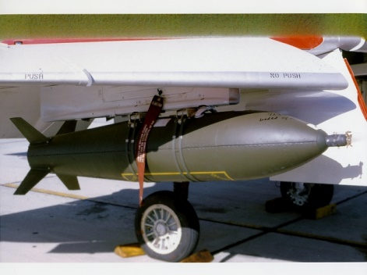Another NOTS developed area weapon isa general purpose, universal dispenser type weapon. Carried and dropped from an aircraft like a bomb, each dispenser during its trajectory spews a large number of anti-personnel grenades over an extensive area to make the ground literally boil with explosives. In our next event, we will demonstrate a substi­tute munition which will simulate the anti-personnel grenade which would be used in combat.

LCDRRochester from Madison, WI, flying a Douglas Skyhawk (BuNo 144925) will attack target posi­tion “W” which is an array of 200 brightly colored balloons intended to simulate troops in tactical deployment.

(Pause for attack):

I would estimate that _____ of the target balloons have been hit. Aerojet General Corporation has the production contract for this dispenser.

EVENT # 17: Two NAF F-8B Crusaders Sidewinder 1-A Firing Demonstration

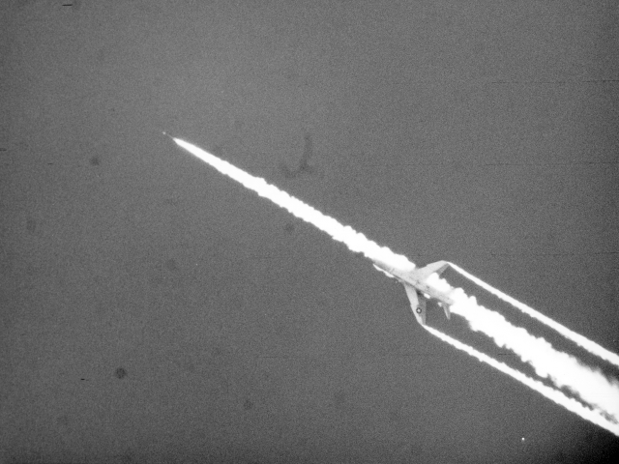Up to this point we have demonstrated primarily air-to-surface weapons, Control of target airspace, however, is essential before airstrikes can be effective. Sidewinder gives our aircraft the necessary means to shoot down enemy aircraft and thus gain airspace superiority.

Sidewinder is an air-to-air, heat-seeking missile. This weapon was conceived by Dr. William B. McLean in 1949. He was assisted by a relatively small group of NOTS scientists and engineers. For his brilliant technical achievement, Dr. McLean received the President’s award for Distinguished Federal Service from President Eisenhower in 1958.

During the past year, Sidewinder 1A has been produced by our NATO allies. The next flight event will hopefully demonstrate that we have successfully transmitted our engineering end production know-how to NATO. Two Crusaders (BuNo 144443 and 144435) led by LCDR Rutledge from Tulsa, OK, will each launch a target rocket and seconds later fire a NATO Sidewinder assembled from components recently shipped here from 9 NATO countries. In order not to miss the impact, I recommend that you keep your eye on the Sidewinder - - the second missile to be fired. (PAUSE) Like the Mojave Desert reptile, Sidewinders strike is guided by a remarkable heat sensor.

The 1A is highly reliable, deadly effective, simple and inexpensive. It is our only post-Korea weapon to have been proved in combat. In 1958 the Chinese Nationalists shot down four Red Chinese MIG’s over Formosa with this weapon. The Sidewinder 1A is used by the Fleet, the U. S. Air Force and our allies. In this country, it is mass produced by General Electric & Philco.

EVENT #18: Two NAF F-8D Crusaders Sidewinder 1-C Firing Demonstration (Sidewinder 1-C and 1-A Elevator Display, Up)

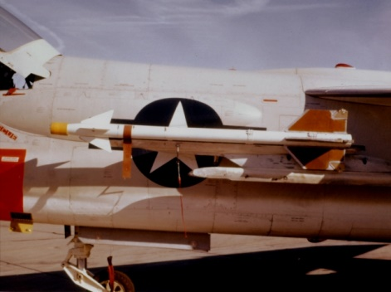Sidewinder 1-C, an advanced model of the Sidewinder 1-A just demonstrated, should be available to the Fleet in early 1964. It gives the pilot of an interceptor aircraft a distinct advantage in aerial combat. This is because it provides a greatly enlarged tactical firing envelope which covers 16 times the volume over that of the 1-A and allows a pilot to attack all types of air targets from longer ranges and more difficult firing positions. This new, improved Sidewinder (next in our demonstration) has greater maneuverability and, by interchanging infra-red and radar guidance heads, gives the interceptor an all-weather capability for either a tail-on or head-on attack.

We demonstrate the Sidewinder 1-C by engaging an airborne target in our next event. Approaching overhead at 5000 ft. altitude is a pilotless Grumman QF-9G Cougar drone which is being controlled from the ground. Two trailing North American DF-1D Furys are stationed as safety aircraft should drone control mal­function. In pursuit and led by LCDR Rochester from Madison, WI, are two Crusaders (BuNo 147047 and 1470149.) Watch while they close on the drone and launch their 1-C missiles.

A high performance motor and modified airframe give the 1-C an ability to attack an enemy flying at speeds up to 2½ times the speed of sound and altitudes up to 80,000 feet.

Additionally a new continuous-rod warhead is exceptionally destructive at all altitudes and can withstand the high temperatures generated in supersonic flight.

EVENT #19: Four VX-5 A-4C Skyhawks Snakeye Demonstration

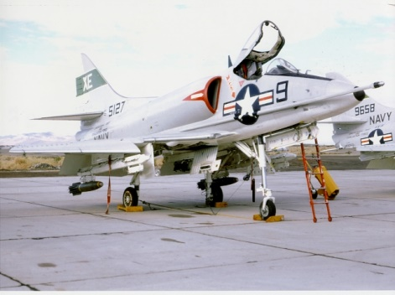Bomb delivery accuracy improves as range decreases. Danger from his own bomb fragments determines a pilot's minimum release range and, in a sense, the limit of his delivery accuracy. NOTS has devised a retarding tail assembly for existing bombs which reduces the minimum safe release range, thus improving accuracy and permitting a variety of high-speed low-level tactics which were previously impossible.

This new retardable weapon is carried in a collapsed condition. Upon release front the aircraft, the tail assembly assumes its retarding con-figuration if the pilot has elected to use this feature. Thus a pilot has the option of using it as a regular bomb for targets which need penetration, or as a retarded bomb for improved accuracy or new tactics.

A flight of Douglas Skyhawks (XE-3, XE-4, XE-8, and XE-9) in two sections, led by LCDR Palmer from Baker, OR, each carrying three 250 pound retardable bombs will attack buildings at the position "M". Here comes the first section in a 10° glide.

(After first section passes)

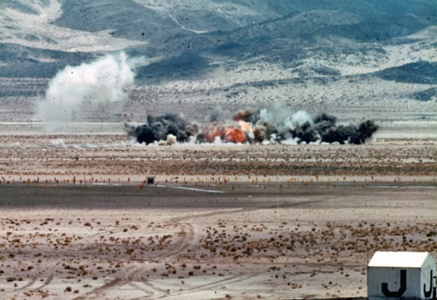The second section now approaches for a fast, low-level, lay-down type delivery. Tactics like this permit penetrations below the radar horizon and visual detection level of enemy defenses.

Developmental assemblies were fabricated by the Douglas Aircraft Corporation. Delivery to the Fleet is expected in 1964.

EVENT 20: Two VX-5 A-4E Skyhawks Rockeye Demonstration

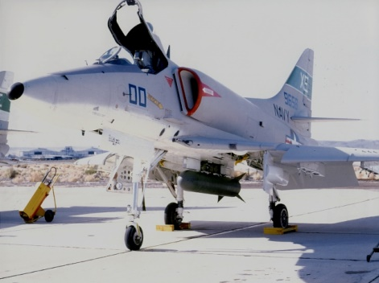Small hard targets are difficult to kill. Many types of ordnance have the ability to put a hard target out of action, if it can be hit. To increase kill probability, NOTS has designed a cluster weapon which disperses bomblets having individual killing power.

The cluster weapon to be demonstrated in our next event uses 96 stockpile 2.75-inch shaped charge warheads. These warheads, or bomblets in this application, are stacked around a ZUNI rocket motor. After release, the rocket fires and disperses the bomblets.

Douglas Skyhawks (XE-00 and XE-22) led by LT Robert Rice from Akron, OH, armed with cluster weapons developed by NOTS will attack the armored vehicles positioned at station "O".

This cluster weapon has a tactical delivery envelope extending from 50 to 400 feet altitude, at speeds up to 600 knots, and will be available to the Fleet by 1964. An improved version using specifically designed bomblets is also under development.

EVENT #21: Two NAF A-4C/E Skyhawks Shrike Delivery

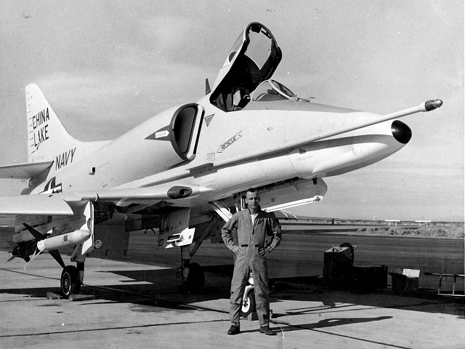In future hostilities, many ground targets will be protected by radar guided surface-to-air missiles, often called SAM sites. To provide us a means of knocking out SAM installations, as well as inhibiting the use of other radars, NOTS has developed the SHRIKE missile.

SHRIKE is an aircraft launched missile containing its own passive guidance system. It is designed to home on active enemy radar antenna.

When locked on by the pilot, the missile is automatically released by a computer System during a variety of maneuvers.

A radar antenna, in line with and beyond position "P" (approximately 10 miles down-range to your far left), is the target for this next event. We are picking up the radar's beam with detection equipment which will impress a background audio-signal on the PA system each time the beam sweeps through our position.

Two Skyhawks (BuNo 147680 and BuNo 149969), led by LT A.L. Tambini from Oklahoma City, OK will approach for a SHRIKE attack. The missiles will be fired from in front of the reviewing stand and will impact approximately 80 seconds later.

(Pause for firing)

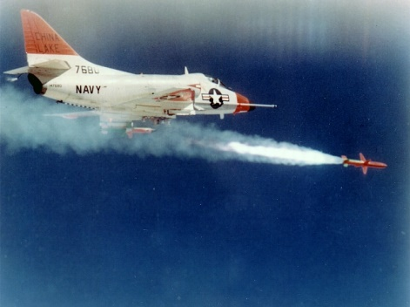Once fired, SHRIKE is on its own thus leaving the pilot free to either initiate further attacks or leave the area. If our demonstration attack is successful, the radar signals on the FA system will suddenly stop. Your television monitor will scan the radar installation at impact so you may observe the damage.

The SHRIKE & system tells the pilot not only that an active radar is in its scan, but also gives information about the nature and location of these radars - - thus allowing selectivity when multiple targets appear.

The SHRIKE warhead consists of 22,000 steel cubes, bonded in an explosive charge. A proximity fuse detonates the warhead at a position which maximizes the fragmentation effect. These steel cubes riddle antenna and wave guides to render radar inoperable.

The SHRIKE missile is compact enough to be carried along as a part of the total ordnance load on light attack aircraft.

(Wait for impact)

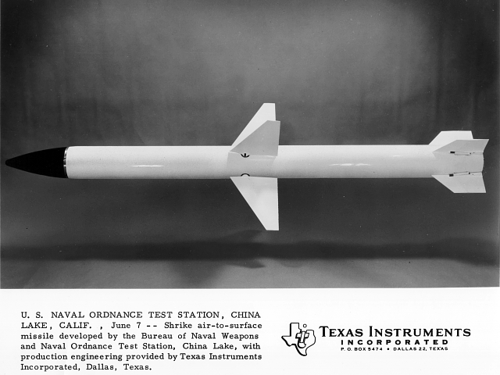 Conceived and developed by NOTS, the guidance system for this lightweight, simple, and inexpensive missile will be manufactured by Texas Instruments, Incorporated.

SHRIKE project development was started under NOTS technical direction in 1958, and was prompted by the effective use of radar-directed, anti-aircraft weapons, used by the Chinese Communists in Korea.

SHRIKE will be delivered to the Fleet in limited quantities later this year.

EVENT # 22 One VX-5 and one VMFA-314 F-4B Phantom II’s 24 MK-82 Bomb Delivery

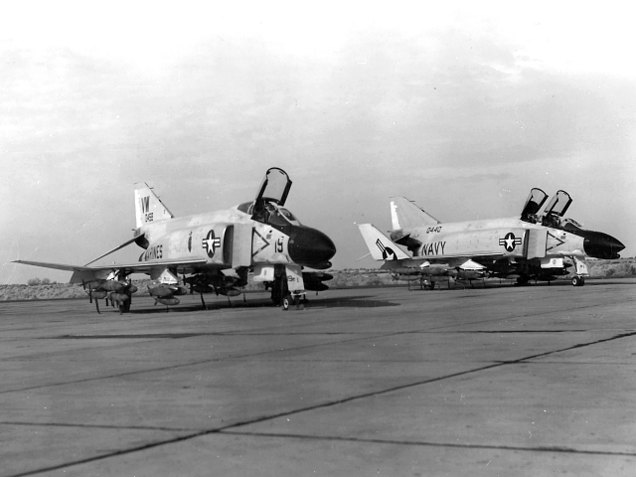When the protecting SAM site has been neutralized by a SHRIKE attack, a concerted carrier air strike on the surrounding targets is possible. We illustrate our future attack capability with sorties by the McDonnell Phantom all-weather fighter.

Two Phantoms (VMFA-314 BuNo 150458, VW-19, and VX-5 BuNo 150440, XE-13) each loaded with 24/500-pound bombs, will complete the SHRIKE initiated attack, the flight, led by (Maj. Hal Vincent or VX-5 Lt. Paul McCarthy) will saturate targets near position "Q" with 12 tons of bombs.

(Pause for attack)

This two-place airplane was designed primarily as an all-weather fighter. It is capable of speeds in excess of twice the speed of sound and holds most of the world performance records. The U.S. Air Force has declared the Navy-developed Phantom II to be the best fighter in the world, and is also procuring this aircraft in quantity. The Phantom also has a potent air-to-ground capability, as you have just witnessed, and can be configured for both missions simultaneously.

EVENT # 23: VX-5 A-3B Skywarrior Cloud Seeding Technique

Man has long sought after a means for controlling the weather. In a tactical sense, the ability to control local weather would give our Armed Forces a powerful weapon and unprecedented operational flexibility.

Massive control of the weather is not yet possible. However, a NOTS developed cloud seeding technique, which may have useful tactical applications, will be demonstrated in this next event.

CDR Charles Lindberg from Valparaiso, IN, flying a Douglas Skywarrior at 15,000 feet will drop two types of devices which release large quantities of silver iodide smoke. Until the development of the propellant used in these units, previous silver iodide generators could produce only a few ounces of smoke per hour.

These devices were developed by NOTS for massive seeding of hurricanes in Project STORMFURY - - a joint U.S. Navy-Department of Commerce effort in hurricane modification. These same techniques could also be used for such applications as closing mountain passes with snow or clearing cold ground fog in the Arctic.

In this event, 160 pounds of silver iodide smoke has been released to produce 10 billion particles. In proper atmospheric conditions, each of these particles would form into a snowflake, releasing large quantities of heat.

These units would normally be dropped at altitudes near 45,000 feet. Today we have dropped them from 15,000 feet so that you nay observe the action at closer range.

EVENT # 24: ZUNI Warhead Static Firing

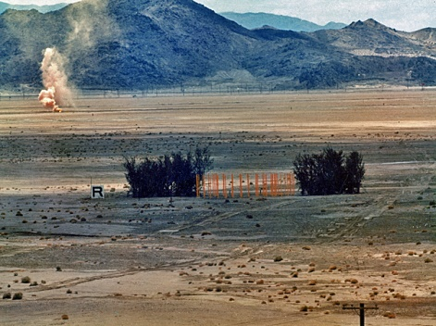A tactical problem which frequently occurs in South Vietnam has generated a need for the weapon which will be demonstrated in this next event.

Guerrillas attack a given area; then, knowing that helicopters will be used to deploy troops to that area, cover nearby clearings, suitable for landing, with vertical bamboo poles. A helicopter pilot, unable to see these poles, cannot safely land. He needs a practical, expedient and reliable means to clear a prospective landing site. A sympathetic group at NOTS, sensitive to the discomforts of cacti and briar patches, has a solution. We call it “Instant Heliport”.

As an illustration of the problem and its solution, your television monitor shows a close-up view of a group of poles staked out in area “R” with trees as a jungle background.

A helicopter, seeking to land there, could drop a ZUNI continuous-rod warhead to clear the landing area. Upon detonation, the ZUNI sterilizer deploys a rapidly expanding ring of steel rod, in a horizontal plane cutting the poles. Result: “Instant Heliport”!

To conserve time, we have planted a ZUNI warhead among the demonstration poles and will now trigger the detonation from ground control.

(Pause for demo)

This weapon will effectively clear an area 60 feet in diameter and is scheduled to ARPA under Project AGILE in the very near future.

EVENT # 25: FAX Demonstration

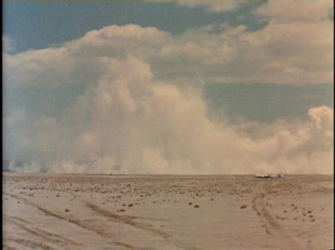 A substantial program in warhead research is being conducted at NOTS to develop more efficient damage mechanisms.

One technique, making use of a detonating vapor, is called FAX - an abbreviation for Fuel-Air-Explosive. FAX has entered the weaponization stage with the develop­ment of an aerial bomb, a bazooka round, and various land mines.

In this demonstration a FAX bomb will be ground-fired adjacent to the B-29 air­craft at position "S". The damage inflicted will be the result of extreme overpressure.

Although the sequence of actions, too rapid to see or hear, there will be two phases. The first, an explosion, rapidly dispenses a highly combustible vapor over a large area, the second, following in rapid succession, detonates the fuel-air-mixture to produce a lethal overpressure. Your television should provide a better look at the effect. Watch, now, as we trigger our demonstra­tion FAX bomb.

(Pause then fire FAX)

A number of FAX bombs are scheduled for delivery to the Advanced Research Projects Agency, under project AGILE in the near future.

EVENT #26: PBX

Another significant program at NOTS is the specialized application of explosives and chemicals to all phases of warfare.

One among these is the use of Plastic Bonded Explosives, PBX. The character of this material permits it to be molded into different sizes and shapes or to be filled with fragments and dye. The characteristics have been exploited in designing warheads for rockets and missiles as well as specialized uses in counters-insurgency warfare.

As an illustration of the fiendish potentialities for PBX, one nasty trick is to make disguised land mines by molding PBX in the shape and color of rocks common to an area. Dropped along roads or paths these rocks will detonate upon any future disturbance. A mechanism is provided which will make than inoperative after a stipulated period of time.

The area 'T' in the foreground and visible on your television monitor has been seeded with explosive rocks made of PBX. In a moment, an unmanned vehicle will be towed through the seeded area. Were this an enemy patrol probing through the area, death would be literally a stone's throw away.

(Pause for Demo)

Explosive rocks have been delivered to ARPA and initial field tests have been completed in South Vietnam,

EVENT #27: Two NPF El Centro TF-9J Cougars RAPEC Ejection

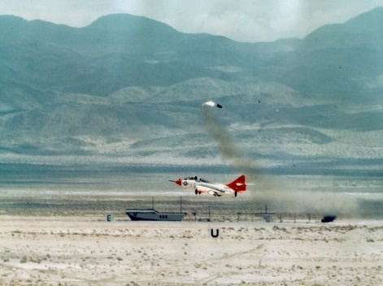Throughout our demonstration, you have witnessed many low flying attack aircraft. Until recently, pilots had a marginal escape capability in the event of an emergency at low altitudes. In 1960, NOTS provided the Fleet with an on-the-deck ejection capability called Rocket Assisted Personnel Ejection Catapult, or "RAPEC". This event will demonstrate RAPEC by ejecting a life-like dummy from a jet trainer.

Two Grumman Cougars (BuNo 142448 & 142440) from the Naval Parachute Facility, El Centro, California, are approaching at 150 knots, 50 feet off the deck. When directly in front of us, the closer Cougar, Lt. Tom Reed from Chicago, Illinois, will eject our standard RAPEC Test dummy, known locally as "SIERRA SAM", from the rear cockpit.

(Pause for Demo)

The acceleration forces experienced with RAPEC are well within acceptable physiological limits. Nearly 100 pilots (both Navy and Air Force) owe their lives to safe ejection with RAPEC.

EVENT # 28: Line Charge

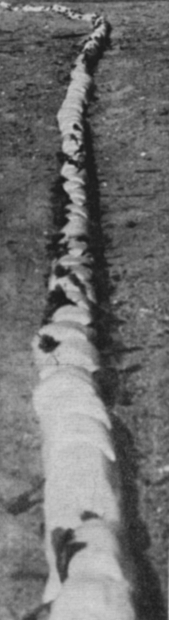A recent innovation developed by NOTS is a novel device for clearing a path through coastal mine fields prior to amphibious landing operations. The device, a sausage-like string of explosive charges, might be carried by helicopters or small craft (such as mine sweepers) and payed out to any convenient length into troublesome mine fields. Tests against inert mines conducted off Key West, Florida, and in Chesapeake Bay, have proved this system to be rapid and effective. It is the only effective method to neutralize pressure type mines yet developed.

In today's demonstration we are substituting the sands of China Lake for the waters of Chesapeake Bay. A 600 foot length of line charge has been strung on the ground at position "U”. The Amy has developed similar techniques for clearing obstacles on land.

Some overpressure from the blast will be felt at the viewing stand. Steady yourselves as we trigger the explosion.

EVENT # 29: Carrier Air Group Eleven Fly-By

EVENT # 30: Smoke Demonstration.

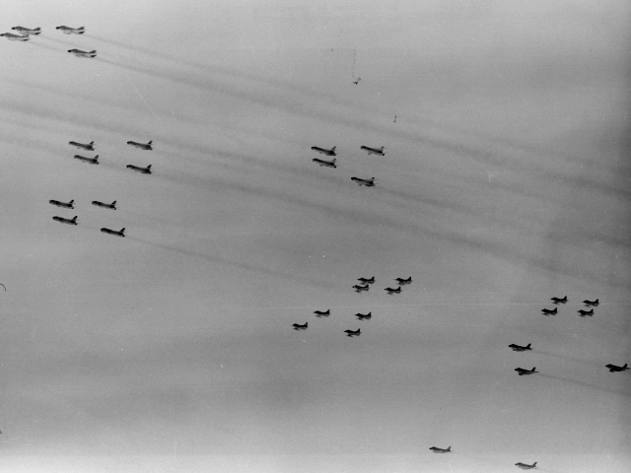Mr. President, distinguished guests: As a finale to our demonstrations, Carrier Air Group Eleven, recently returned from duty in the Western Pacific and operating from the U.S.S. Kitty Hawk at sea, approaches in formation to salute you. The airgroup commander is CDR O'Neil of Boston, MA. A-4 Skyhawk aircraft in their wake will lay down a covering smoke screen to draw a curtain ever our demonstration area and to close our program. This act will conclude your briefing at the instrumented ranges of the Naval Ordnance Test Station.

Within a few minutes you will be escorted on a tour of the Station. May we wish you continuing fair winds and tides, and pledge that that might and expanding knowledge of the United States Navy stands ready to assert its role in National Defense.

Following the tour of Michelson Lab. President Kennedy returned to the airfield and congratulated and thanked the pilots and crews of the aircraft that participated in the aerial weaponry demonstration.

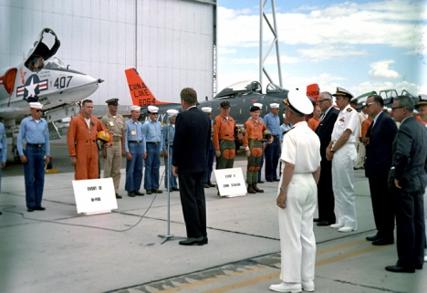Pilot at left of J President Kennedy is NAF Lt. Dave Callahan, HIPEG demo (Event 12) and the VF-162 Hunters pilots who flew the 20mm strafing demo (Event 11) and to the right of JFK is NAF Lt. Rod Sikes who flew the 50 cal. demo in the DT-28B (Event 10). Aircraft in the background are DF-1D Fury BuNo 136064 (Event #16) and DT-28B Trojan BuNo 138355 (Event #10). Photo from the John F. Kennedy Presidential Library and Museum, Boston.

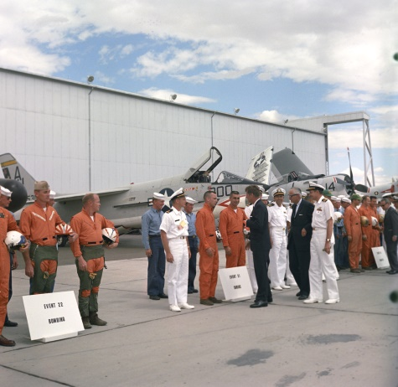President Kennedy speaks with Event 21 (SHRIKE) pilots Lt. Tony Tambini & Lt. Gus Jones. At left are the VMFA-314 RIO Ed Edelen and the VX-5 Vampires RIO. At far right are three of the Event 19 (Snakeye) VX-5 pilots Lt. T Palmer, USMC Capt. Ray Powell, Lt. Boyd or Lt. Barr. Aircraft in the background are VF-162 Hunters F-8A Crusader AH-200 and VX-5 Vampires A-1H Skyraider BuNo 139731, XE-14. Photo from the John F. Kennedy Presidential Library and Museum, Boston.

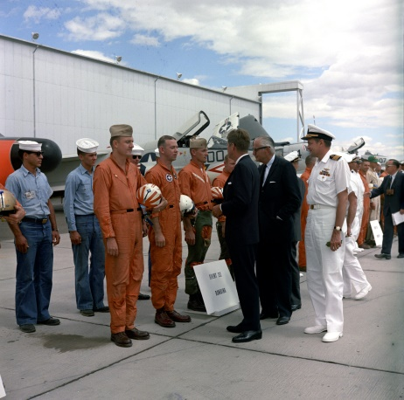President Kennedy speaks with Event 22 pilots VMFA-314 Maj. Hal Vincent, VX-5 Lt. Paul McCarthy, VMFA-314 RIO Ed Edelen & VX-5 RIO (unknown. Aircraft in the background are NPF El Centro TF-9J Cougar, VF-162 Hunters F-8A Crusader AH-200 and VX-5 Vampires A-1H Skyraider BuNo 139731, XE-14. Photo from the John F. Kennedy Presidential Library and Museum, Boston.

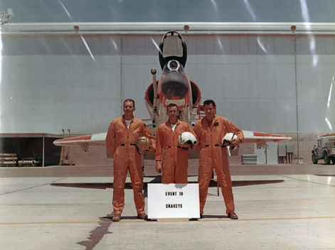VX-5 Vampires Event 19 pilots LT Bob Boyd, LCDR Gary Palmer & USMC CAPT Ray Powell in front of NAF China Lake NA-4C Skyhawk BuNo 145063.

Presidential Address to Officers and Men

7 June 1963

The following is a paraphrase of the comments of President John F. Kennedy to the pilots who participated in the weapons demonstration at NOTS, China Lake, California on 7 June 1963.

"I wish to take this opportunity to thank each of you for your fine efforts in putting on this weapons demonstration today. I was greatly impressed by the skill of the pilots in delivering these weapons. Today’s weapons are the product of continuing advances in technology. As the weapons and weapons systems become more tech­nically advanced, it is necessary for the pilots to become more technically advanced and more technically proficient: in their use.

"While the pilots of World War II aircraft had longer time over target and could make repeated attacks, the modern aircraft has little time over target and cannot normally repeat attacks. Therefore, the weapons of today must have the capability of doing their job the first time rather than as a result of repeated delivery. As a result of this advanced weapons technology and the speed of modern aircraft you, the pilots, must have the requisite talent and skill to accomplish your mission, As President of the United States, I can say that you have amply demonstrated that here today."

Departing Remarks By The President

7 June 1963

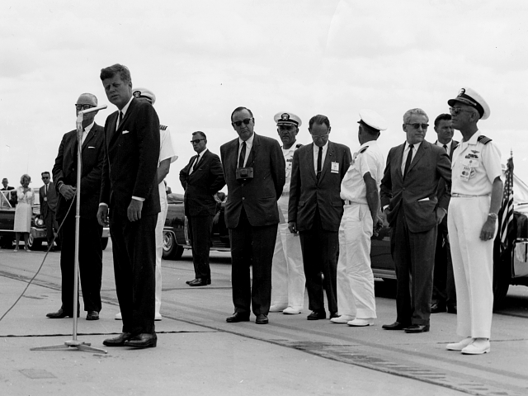"Captain, Mr. Secretary, I want to express a warm word of appreciation to all of you. We are completing a trip through the military installations of the United States which started two days ago.... the Air Force Academy in Colorado, down to New Mexico, the testing at White Sands, and now here to California-San Diego, the Marine Corps, on the Kitty Hawk last night, and now to see the work that you are doing here.

"I must say I am impressed by two things, particularly, in this journey to California; first, I have never seen any healthier looking children - which it the best advertisement that I have seen for this state - and I want to express com­mendation to all of the mothers and fathers who are bringing up what looks like some of our best future citizens.

"I also want to express a word of thanks to all of you who work for our country in this decade, those of you who fly, those of you who maintain the planes, those of you who nay work in research, those of you who may work in Civil Service. I think all of us today in 1963 are proud of the fact that in one way or another, all of us have an opportunity to serve the United States. This is the last, best hope, and I think in 1963 I cannot think of a prouder statement, when asked what your occupation may be, than to say, 'I serve the United States of America'.

"We want to thank all at you."